Thomas Courtney

3175353  UON

PHYS2170: Semiconductor Physics



Contents

Abstract 2

Introduction 2

Discussion 4

Part One – Two Square Wells 5

Energy Levels 5

Waveforms 6

Part Two – Regular Lattice of Wells 7

Part Three – Irregular Lattice of Wells 8

Conclusion 10

Bibliography 10

# Abstract

This report details the effects of manipulating the properties of a lattice structure in a computer simulation based on the Kronig-Penney model. It was shown that for a two-well lattice increased wave interaction increased the separation of energy levels in groups to satisfy Pauli’s exclusion principle. For a regular lattice a larger number of wells increased the number of allowable energies. In an irregular lattice structure reducing the depth and width of a single well reduced the energy gap between energy bands in the material.

# Introduction

### Kronig-Penney Model

Semiconductors exhibit unique conductive properties. Semiconductors have been utilised, most notably, to create computers. This was only possible because of an understanding of their physical behaviours. These behaviours may be modelled using quantum mechanical systems. The Kronig-Penney Model approximates the potential energy of an electron in a material using a series of equally spaced quantum wells (see Figure 1). This is known as a periodic lattice.

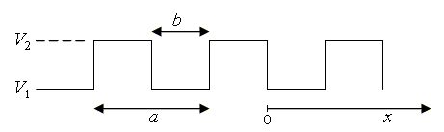

Figure 1: Kronig-Penney Model of an electron in a periodic lattice (source: Graz University of Technology)

This enables the use of Schrödinger’s Equation to model the interaction of electrons in structure of greater complexity such as molecules and solids. The model, by giving the allowed energies of the electrons, gives a crude approximation of the electrical behaviour of a material. The magnitude of the energies and their spacing tells us how conductive or nonconductive a material would be (see Figure 2).

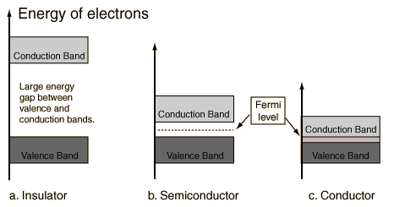

Figure 2: Energy bands of a material (Source: HyperPhysics)

The smaller the “band gap” between the valence and conduction band and the larger the conduction band the greater the conductivity of the material. The properties may be manipulated through “doping” which in the Kronig-Penny model is simulated by creating irregularities in the array of wells such that the wells are no longer periodic or square. Furthermore, by manipulating the number of wells, their separation and dimensions you may simulated different scenarios.

The solutions for Schrödinger’s Equation for a periodic structure are called “Bloch Functions” (see Equation 1) that describe the wavefunctions of particles in a periodically repeating environment.

$$Ψ\left(x\right)= e^{ikx}u_{k}\left(x\right) \left(1\right)$$

The Kronig-Penney model determines the allowable energies using transcendental equation (see Equation 3) which may have a value of only ±1. Any energy that yields a value outside of this range is not allowed.

$$\left(\frac{mV_{0}ab}{ħ^{2}}\right)*\left(\frac{\sin\left(αa\right)}{αa}\right)+cos\left(αa\right)=\cos\left(ka\right) (2)$$

$$Where α^{2}=\frac{2mE}{ħ^{2}}$$

# Discussion

The Kronig-Penney model was used to calculate the energies for a periodic lattice of wells of depth 300eV and width 0.2nm. The allowable energies obtained are comparable to energies for a single well of the same width and depth, see Table 1 & 2.

|  |  |
| --- | --- |
| **Allowable Energy Level** | **Energy (eV)** |
| 1 | 9 |
| 2 | 37 |
| 3 | 83 |
| 4 | 149 |
| 5 | 323 |

Table 1: Allowable energy levels for a periodic lattice calculated using the Kronig-Penney Method. Depth 300eV and width 0.2nm.

|  |  |
| --- | --- |
| **Allowable Energy Level** | **Energy (eV)** |
| 1 | 7.59 |
| 2 | 30.28 |
| 3 | 67.8 |
| 4 | 119.56 |
| 5 | 184.33 |
| 6 | 258.57 |

Table 2: Allowable energy levels for a single well of depth 300eV and width 0.2nm.

The difference in results shows that that the Kronig-Penney Model is an approximation, despite this is can still be used to develop a high-level understanding of the electrical properties of a material.

## Part One – Two Square Wells

### Energy Levels

By simulating only two quantum wells the effect of altering their separation distance was isolated. For two wells, four energy levels were possible and resided in two groups separated by an energy gap. Increased well separation caused the difference between levels within groups to increase.

This behaviour is explained by Pauli’s Exclusion principle. It states that no two electrons may occupy the same quantum state. By bringing the wells closer together the waveforms are forced to reside in the same space, nature’s way of dealing with this is to create more available space i.e. more energy levels. A potential well is analogous to an atom which has associated electrons. More energy levels must be created to accommodate more electrons. Figure 4 displays the energy levels at different separations.

Figure 4: Allowed energies for a two-well lattice of depth 300eV and width 0.05nm with varying separation. (Luke I didn’t include the Single Well for comparison as it was near impossible to do well in excel in the same chart as the rest of the data).

We also see that for wells very close together at 0.01nm and 0nm the number of available states reduces to 3. This may be as the increased wave interactions have diverged the energy levels so much that one of the magnitudes is too great to reside in a well of those dimensions. The energy levels of the two-well structure are similar to that of a single well of the same dimensions.

|  |  |  |  |  |  |
| --- | --- | --- | --- | --- | --- |
| **Separation (nm)** | **0** | **0.01** | **0.05** | **0.1** | **Single Well** |
| **1** | 24.6 | 60.96 | 69.52 | 70.29 | 70.08 |
| **2** | 96.65 | 97.88 | 71.09 | 70.31 | 247.32 |
| **3** | 208.44 | 251.71 | 241.73 | 246.92 | - |
| **4** | **-** | - | 258.81 | 249.1 | - |

Table 3: Allowed energies for a two-well lattice of depth 300eV and width 0.05nm with varying separation.

### Waveforms

The wavefunctions for the double well were similar to those in the single well of the same dimensions (see figures 3&4).

It looks like the waves in the double well are the same as in the single well but have continued propagating through the wells, repeating periodically. There are four energy levels in the double-well lattice, two of which mirror exactly the shape of the single well and two others that are the inverse of the single well shapes.

Bloch’s theorem states that each wavefunction is an energy eigenstate [1] (i.e. corresponding to an eigenvalue of a wavefunction) and that each wave may be described by a Bloch function (see equation 1). Bloch functions may be used to calculate the predicted behaviour of electron’s in a periodic lattice helping to understand the properties of the material they reside in.

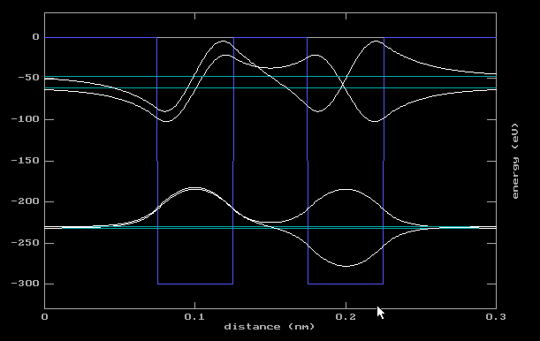

Figure 4: Wavefunctions for a double well of depth 300eV, width 0.2nm and separation 0.1nm

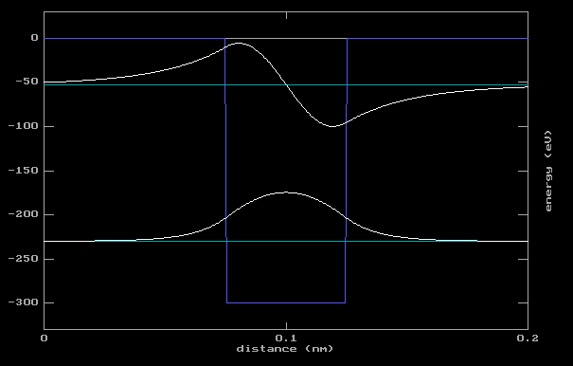

Figure 5: Wavefunctions for a single well of depth 300eV and width 0.2nm

This shows that electron behaviour in a material is periodic and hence predictable.

## Part Two – Regular Lattice of Wells

A regular lattice of a greater number of wells allowed for a greater number of allowable energy levels. The well dimensions were all 300eV deep, 0.05nm wide and 0.05nm apart. The energy levels were discretely grouped into two “bands” and the number of energy levels in each band were directly proportional to the number of wells. As discussed in Part One of the discussion the increased energy levels are explained by Pauli’s Exclusion principle.

The energy levels are distinctly grouped into two “bands” which may be described as the conduction and valence bands of the material being modelled. Valence electrons are those electrons that reside in outer most “complete” shell of an atom. Conduction electrons are those that reside in an incomplete outer shell of an atom and so are “loose” and may be transferred to other atoms. Therefore, the more electrons in the conduction band of a lattice, the greater the current carrying capacity of that lattice structure or material.

The number of levels is proportional to the number of wells in the lattice, where n is the number of wells, the number of energy levels is 2n (see table 6).

|  |  |
| --- | --- |
| **Number of Wells** | **Number of States per Group** |
| 1 | 1 |
| 4 | 4 |
| 6 | 6 |
| 12 | 12 |

*Table 6: Number of allowable energy levels for a periodic lattice of wells*

The magnitude of the “boundary” energy levels were similar to that of a single well and double well for lattices of sizes 4, 6 & 12 (see tables 5 & 7). These are the energy levels that are on the boundaries of the two distinct energy bands.

|  |  |  |  |
| --- | --- | --- | --- |
|  | **Number of Wells** | | |
| **Boundary States** | **4** | **6** | **12** |
| 1 | 69.58 eV | 66.6 eV | 67.93 eV |
| 2 | 71.95 eV | 69.36 eV | 70.82 eV |
| 3 | 243.59 eV | 231.34 eV | 234.52 eV |
| 4 | 263.35 eV | 258.47 eV | 264.39 eV |

Table 7: Boundary state energies for a periodic lattice of square wells of depth 300eV, width 0.05nm and separation 0.05nm

Though there is an increase in the number of energy levels the variation in their magnitude is very small. Compared to those energies calculated using the Kronig-Penney model however we see significant variation (see table 1).

## Part Three – Irregular Lattice of Wells

Manipulation of semiconductor behaviour is achieved via “doping”. Doping is where impurities are introduced to a semiconducting element such as silicon or germanium. These impurities may be simulated in the Kronig-Penney model by creating irregularities in an otherwise periodic lattice structure.

In a twelve well lattice structure of 300eV deep wells of width 0.05nm and separation 0.05nm the depth of the sixth well was made to be 250eV. This irregularity created different boundary energies as compared to the regular twelve well lattice of the same dimensions (see tables 7 & 8).

|  |  |
| --- | --- |
| **Quantum Number (n)** | **Energy (eV)** |
| 1 | 68.03 |
| 12 | 115.11 |
| 13 | 235.25 |
| 24 | 282.4 |

Table 8: Boundary energies for an irregular periodic lattice of 300eV depth, 0.05nm width and separation 0.05nm. Sixth well depth 250eV.

The same distinct two groups appear however the magnitude of the boundary states for the “doped” lattice however the magnitude for the higher boundary state for each group has a much larger magnitude. This means that the range of each group is larger and the energy gap between the two bands is smaller. This means that less energy is required to transfer an electron from the valence band to the conduction band, i.e. less energy is required the material to conduct. See figures 6 & 7 for difference in band gap and band widths.

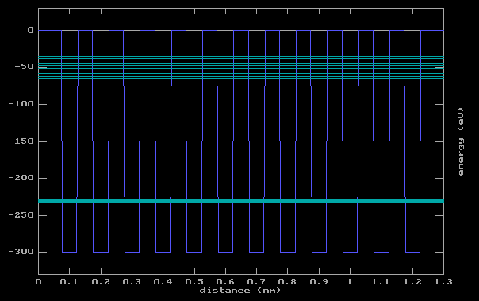

Figure 6: Allowed energy levels for a regular periodic lattice of 12 wells of depth 300eV, width 0.05nm and separation 0.05nm

Any protruding energy states above the “Fermi Level”, which is the topmost boundary state of the valence band, will help to reduce the energy required to transfer to the conduction band.

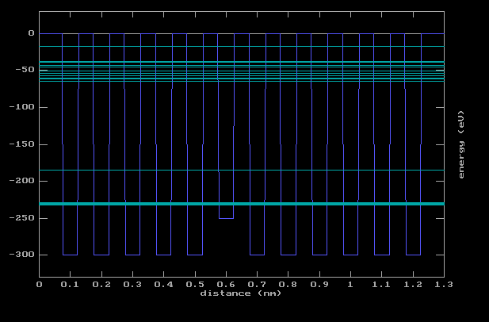

Figure 7: Allowed energies for an irregular lattice of 12 wells depth 300eV, width 0.05nm and separation 0.05nm. The sixth well is 250eV deep.

The outlying energy level for each band significantly reduces the energy gap between bands which is an important feature of semiconductors when using them in practical settings.

By reducing the width of the sixth well from 0.05nm to 0.04nm the energy levels may be altered further (see figure 8). The narrowing of the well further extends what is now looking like an extra energy band of a single state into the band gap. The energy level can be used to help bridge the gap between the two levels and reduce the energy required for semiconductors to conduct.

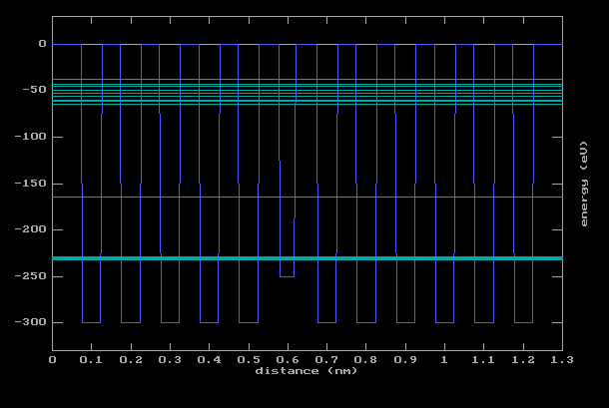

Figure 9: Energy levels for a periodic lattice of 12 wells depth 300eV, 0.05nm wide and separation 0.05nm. Sixth well is 250eV deep and 0.04nm wide.

# Conclusion

The Kronig-Penney model though only approximation still conveys the energy band structure of a material by modelling it as a periodic lattice. This information is sufficient to predict the electrical conductivity of a material.

Potential wells may be used to model atoms in lattice structures, where their addition to the lattice introduces a greater number of allowed energy levels per well proportional to 2n where n is the number of wells. The proximity of the wells dictates the separation of the energy levels as the closer they are together the further apart the energies must be to satisfy Pauli’s Exclusion Principle.

The energy levels occur in two distinct groups in a regular lattice. These groups are analogous to the conduction and valence band of electrons in a material. The boundary states of these groups is of a consistent magnitude whether the lattice be made of 2 wells or 12.

“Doping” of semiconducting materials may be modelled using the Kronig-Penney model by introducing irregularities into an otherwise regular and periodic lattice. By reducing the width and depth of a single well the energy gap separating the two bands could be reduced by a boundary state sliding up into the band gap. This has practical applications as it reduces the energy required for a semiconductor to transfer an electron from the valence band to the conduction band.

# Bibliography

|  |  |
| --- | --- |
| [1] | F. Bloch, "Über die Quantenmechanik der Elektronen in Kristallgittern", 1928. |